Pokhara University

Level: Bachelor | Semester – Spring | Year : 2007
Programme: BE |  | Full Marks: 100
Course: Signal and System |  | Time : 3hrs.

Candidates are required to give their answers in their own words as far as practicable.
The figures in the margin indicate full marks.

Attempt all the questions.

 | - Define signal and system. Also, discuss various characteristics of system with example.  - For the given signal x(t), find the output signal y(t) if it passes through the given system  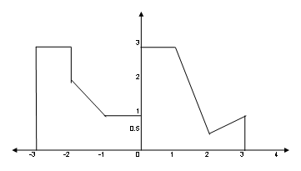  Delay by 4  Time scale by 4/3  x(t)  Signal Multiply by 3  y(t) | 7  8
 | - Determine the exponential Fourier series coefficients of the periodic signal x(t) defined as |2cos(πt/2)| in the rising part and zero elsewhere which is given in figure below:  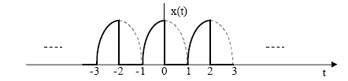  - Why Fourier Transform is important in the field of communication and also write the properties of Fourier Transform. | 8  7
 | - Find the Fourier transform of the signal defined as:  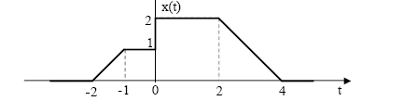  - Explain the DFT calculation by linear transformation method, using this method calculate DFT of the following sequence.  x[n] = {2, 3, 2, 1} | 8  7
 | - Determine the circular convolution of the sequence  x₁(n)={2, 5, 3, 6}  x₂(n)={4, 3, 2, 2}  - Derive the condition for an LTI System to be  i) BIBO stable  ii) Causal | 8  7
- 8 | - What is the output of LTI system whose impulse response is  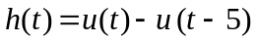and input is defined as: 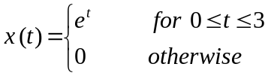  - Why direct form-two realization of LTI system is better? Construct direct form-two realization of LTI system described by difference equation which is given below.  2y(n) + y(n - 1) - 4y( n- 3) = x(n) + 3x(n - 5) + 2x(n – 2) | 8  7
 | - What are the differences between FIR and IIR system? Explain with examples.  - Define Ideal Low pass filter. Also, justify why any ideal filter cannot be realized in practice? | 7  8
 | Write short notes on (Any Two):  - Power spectrum density function  - Distortion- less transmission line  - Negative frequency and its significant | 2×5

